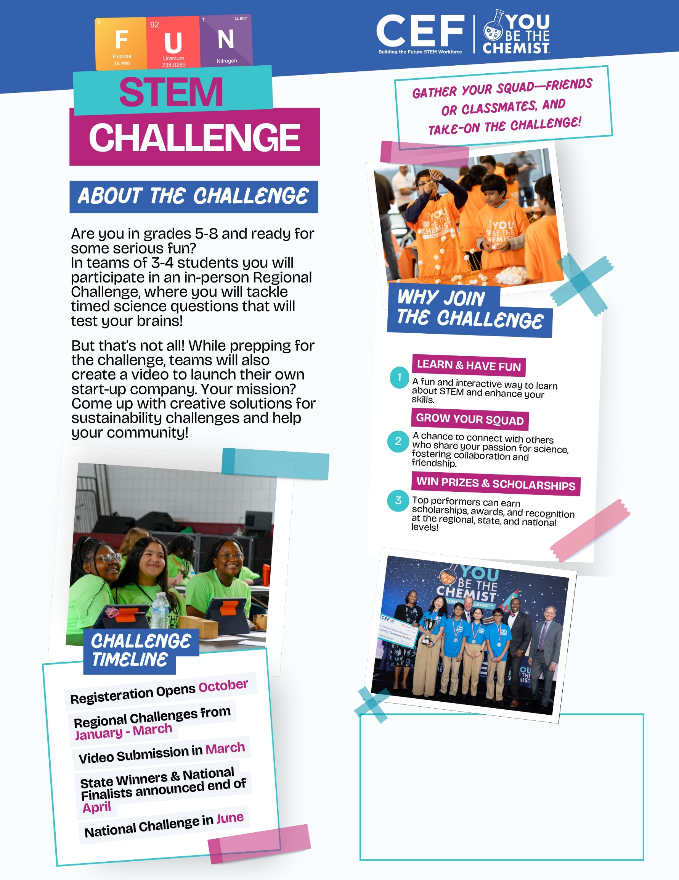

**ADD YOUR OWN TEXT HERE!**

*It could include a link or QR code directing students to a form to express interest, as well as your name or room number for any questions or further information.*